Islington Living Streets Campaign Manifesto

Challenges: the Council has taken steps to make walking and cycling safer, and improve public spaces, but faces significant challenges which require new responses:

• Growth – The population is expected to increase by 29,000, 2016-31.
• Car ownership – According to TFL 74% of households do not have access to a car – so only walk, cycle, or use public transport.
• Transport mode: walking accounts for 42% of all trips orginating in the borough, car/motor cycle, only 21%.
• Rat-running – The transport network is under great pressure from commuters.
• Inequality – Poorer households are far less likely to have access to a car than richer ones.
• Danger– in 2016, fatal and serious casualties: 5 car occupants, 25 cyclists, 27 pedestrians, and they occur disproportionately in or near areas of greatest deprivation
• Obesity – 39% of Year 6 children are obese or overweight.
• Air pollution – 7.9% of mortality is attributable to long term exposure to PM2.5 (41% higher than UK average); and there is a strong link between pollution and deprivation.

CHANGES TO TRANSPORT ARE ONE OF THE MOST EFFECTIVE WAYS OF IMPROVING PUBLIC HEALTH, REDUCING INEQUALITY AND CREATING A BETTER ISLINGTON

Our vision: “Streets for People: we call for a cleaner, happier, healthier, more equal Islington, learning from progressive neighbouring boroughs”.

Low-traffic, attractive, liveable neighbourhoods that remove rat-running traffic from residential and shopping side roads, provide a network of less polluted, safe streets and attractive public spaces which enabled people of all ages and abilities to walk and cycle and enjoy where they live. See what has been achieved in Walthamstow: www.enjoywalthamforest.co.uk/about-mini-holland/

How can this be achieved? We call on the political parties to commit to introducing the following policies:
- Low Traffic Liveable Neighbourhoods – Create networks of streets where through-traffic is banned; commit to make a large scale Liveable Neighbourhood Bid to TFL
- A network of routes for pedestrians – wider pavements; more/better crossings and junctions; improve the Quietways; pass the buggy test; significantly reduce parking spaces - for visitors and second cars and on bus routes.
- Safer streets – Enforce: 20 mph limit, controls on illegal parking; support Mayor of London’s Vision Zero; tackle crime on streets
- Healthy streets – Combat air pollution and obesity; commit to introducing 20 school streets by 2022; start a public health campaign on the benefits of active travel delivered through schools and GPs.
- Car-free days and weeks – especially on shopping streets to show how good life can be
- Road traffic reduction – set a target to reduce traffic by 2022 and policies to achieve the target, including the closure of rat runs, especially on Quietways - Traffic can disappear if roads are closed http://www.onestreet.org/images/stories/Disappearing_traffic.pdf
How our streets could be transformed
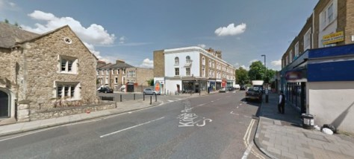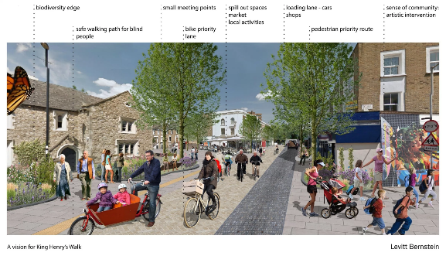

https://www.islington.gov.uk/~/media/sharepoint-lists/public-records/environmentalprotection/businessplanning/plans/20122013/20120530lipmaindocument.pdf
http://content.tfl.gov.uk/technical-note-12-how-many-cars-are-there-in-london.pdf
http://content.tfl.gov.uk/islington-june-2017.pdf
https://www.islington.gov.uk/~/media/sharepoint-lists/public-records/environmentalprotection/businessplanning/plans/20122013/20120530lipmaindocument.pdf
46pc of AB households have access to a car, 35pc of DE households (Census, 2011)
https://tfl.gov.uk/corporate/publications-and-reports/road-safety
https://www.islington.gov.uk//~/media/sharepoint-lists/public-records/publichealth/information/factsheets/20142015/20141021childhoodobesityfactsheetseptember20141
https://www.london.gov.uk/sites/default/files/air_quality_for_public_health_professionals_-_lb_islington.pdf
TFL has established a Liveable Neighbourhood Fund to which Councils bid. Liveable Neighbourhoods can also be created more cheaply by used bollards or even planters
Quietways are routes for pedestrians and cyclists which are supposed to be on low traffic back streets – but traffic levels are often high
The Mayor of London’s Vision Zero commitment plans to eliminate all fatalities and serious injuries on the road by 2041
‘School streets’ involve the closure of roads near schools at beginning and end of School Day

